Order Of Service

Singing: Psalm 42-43—CW page 82

Reading: Psalm 123

Opening Hymn: TLH 518 vs 1-4

Reading: Hebrews 12:1-11

Request Hymn: CW Supplement 749

Reading: Luke 16:16-31

Sermon Hymn: TLH 518 vs 5-7

Sermon Text: Song Of Solomon 1:6

My Mother’s Children

Prayer

The Apostles’ Creed, TLH page 12

Holy Communion

The Lord's Prayer

The Blessing

Closing Hymn: TLH 514

* * * * * * * * * * *

Bible Study: Lambs: Romans 12:16; Share Happiness
Sheep: Proverbs 3:21-26; Your Choice
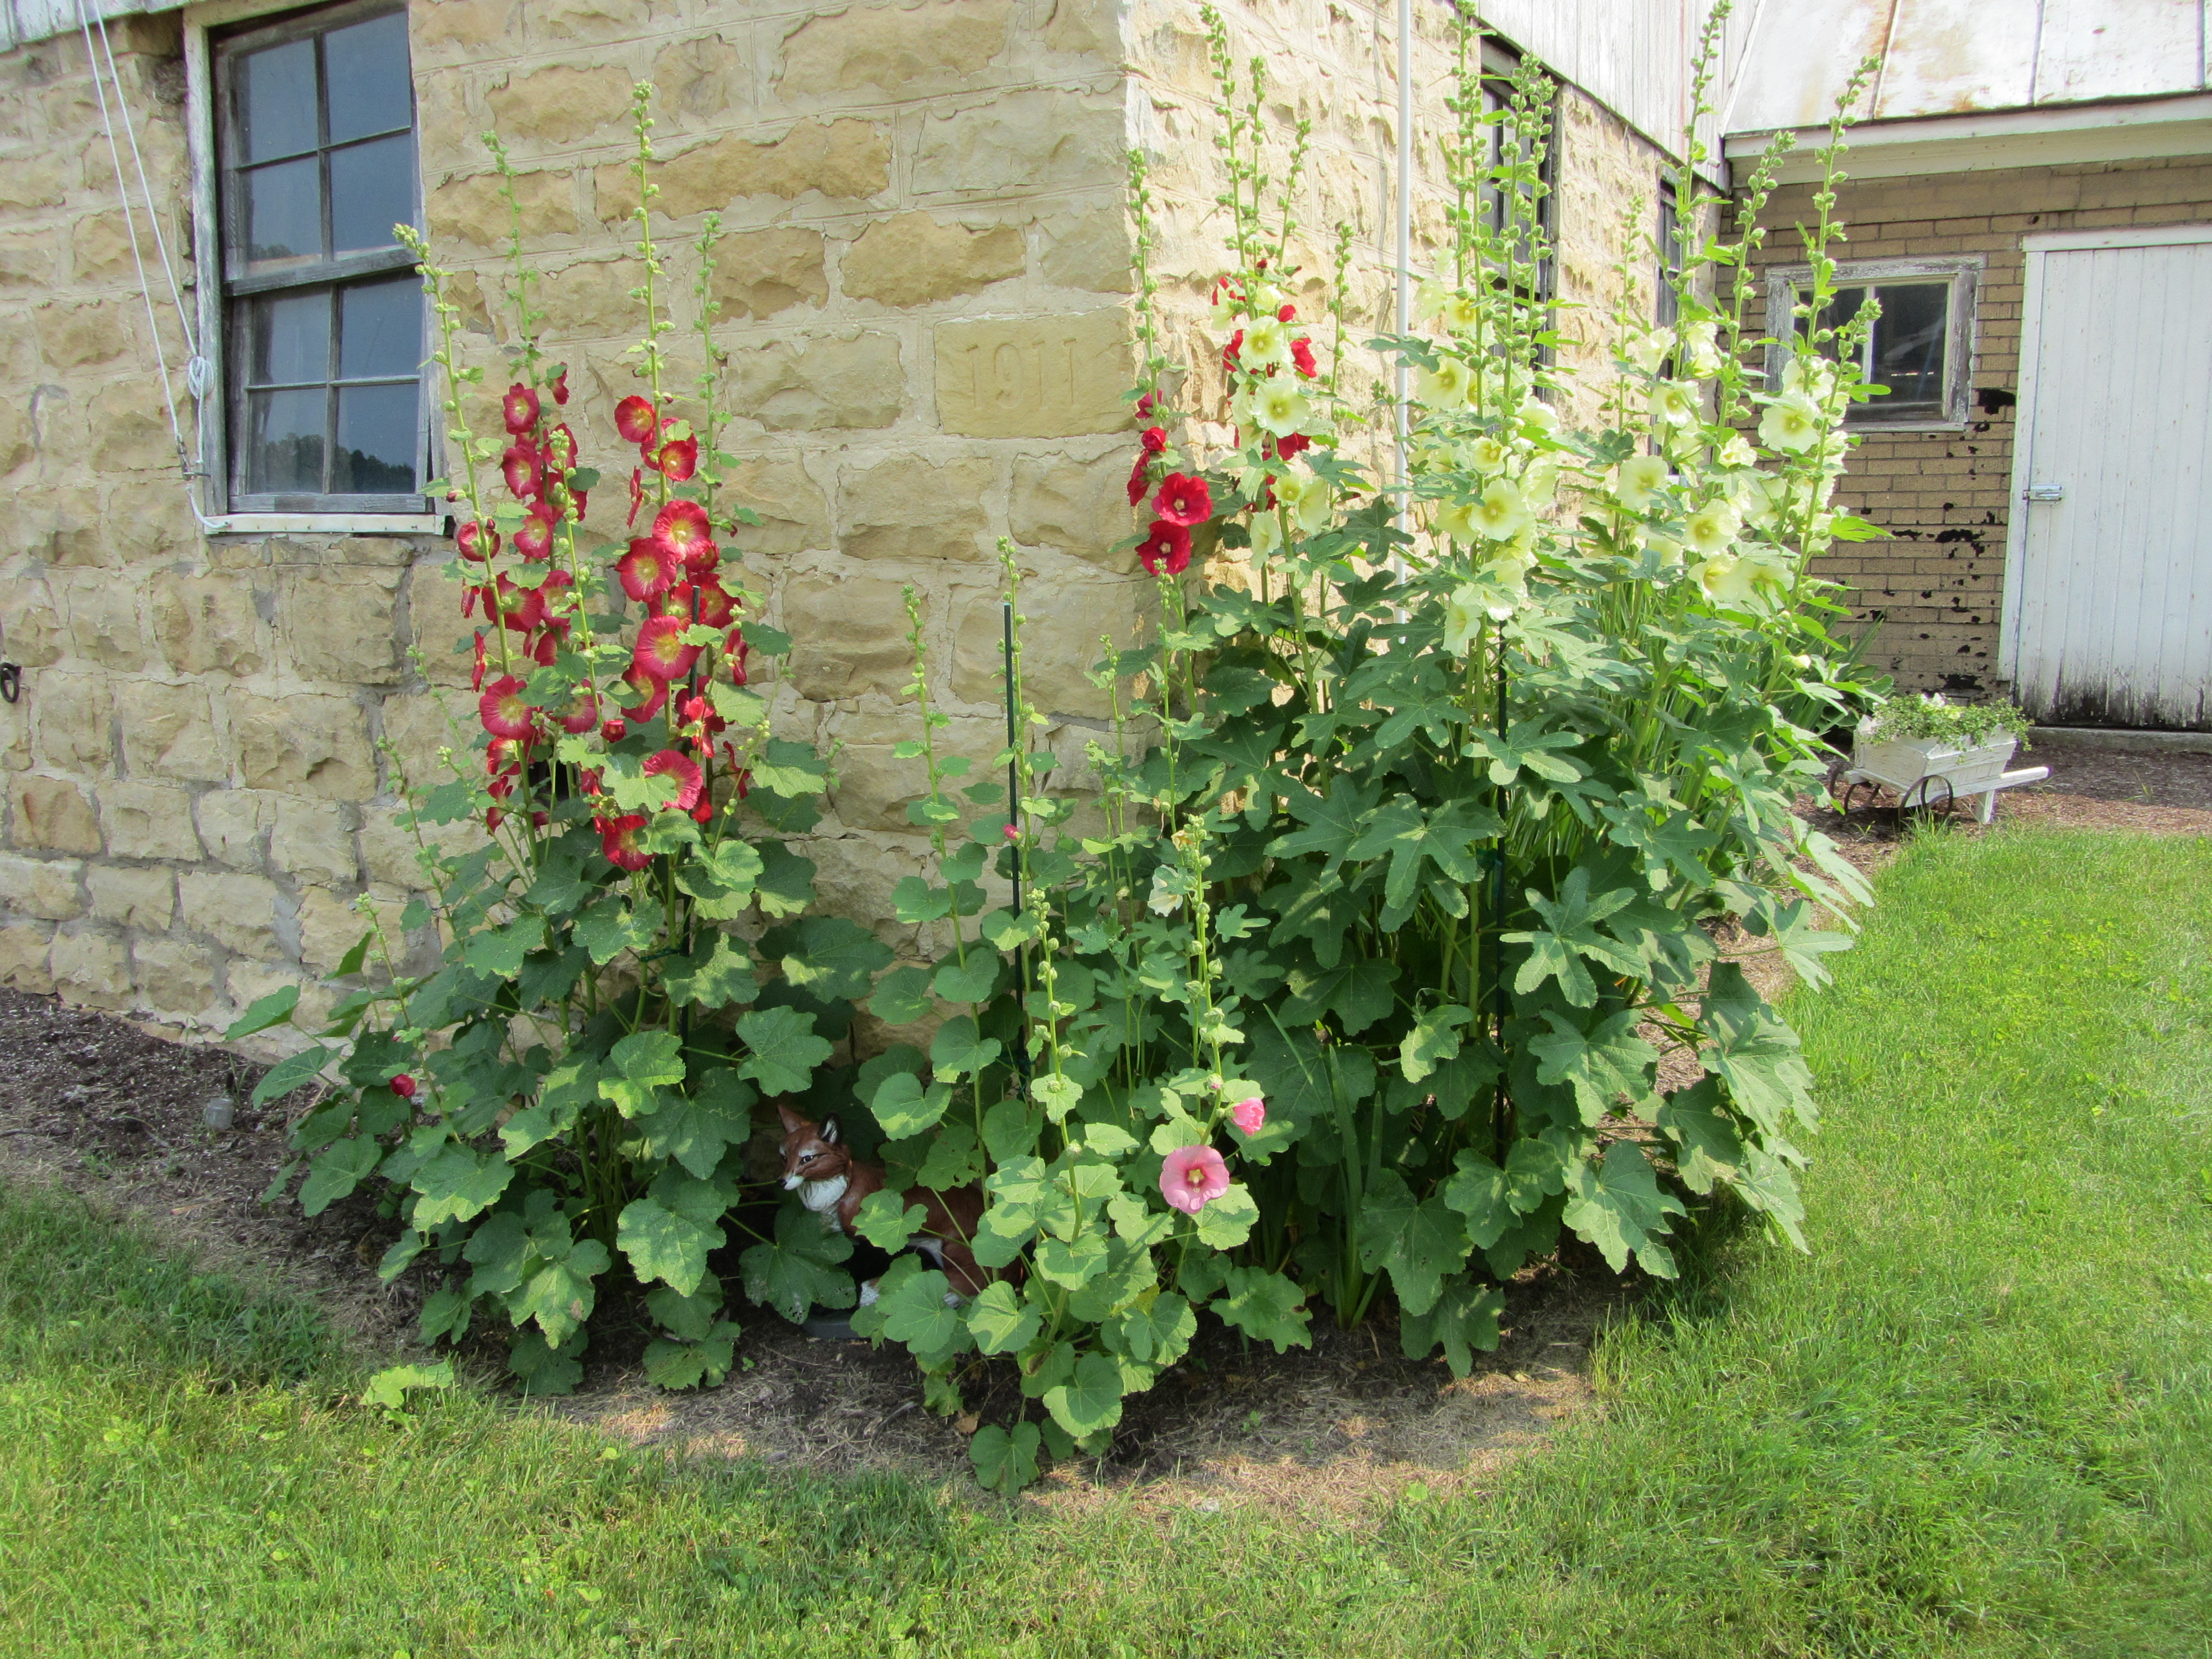

Flowers Appear On The Earth

Water
Of
Life

19 July 2015

W A T E R O F L I F E

Independent Christian Church—Conservative Lutheran Doctrine

Worship Service: 9:30 a.m. Bible Study: 10:45 a.m.

Larry Cooper, Pastor E-Mail address:
111 N. Ridge Road lcooper@wateroflife.cc
Coon Valley, WI 54623 Web Site:
Phone: (608) 452-2105 www.wateroflife.cc

* * * * * * * * * * * * * * * * * * * * * * * * * * *

Sermon Text: Song Of Solomon 1:6

My Mother’s Children

* * * * * * * * * * * * * * * * * * * * * * * * * * *

6: Look not upon me, because I am black, because the sun hath looked upon me: my mother's children were angry with me; they made me the keeper of the vineyards; but mine own vineyard have I not kept.

Revised List—not necessarily in chronological order:

Different Parties In SOS:

1—The Bridegroom, Christ
2—The Bride, his Church
3—Daughters of Jerusalem
4—Watchmen
5—three score queens (6:8)
6—fourscore concubines (6:8)
7—The daughters (6:9) (# 4 ?)
8—the mother
9—the mother’s children
10—companions (1:7; 8:13)
11—shepherds (1:8)

* * * * * * * * *

Last week we saw the Bride speaking with the mysterious daughters of Jerusalem, who appeared suddenly on the scene. The term “daughters of Jerusalem” occurs eight times in the KJV. Seven of these times are in the Old Testament—all of which are found in the Song Of Solomon. The eighth occurrence is found in Luke 23:27-28—“ And there followed him a great company of people, and of women, which also bewailed and lamented him. But Jesus turning unto them said, Daughters of Jerusalem, weep not for me, but weep for yourselves, and for your children.”

Now this morning, another group of people takes center stage. They are called “my mother’s children.” With this group the Bride meets with open hostility. In her own words—“My mother’s children were angry with me!”

Like the daughters of Jerusalem, the mother’s children were also members of the visible church. But unlike their counterparts, the mother’s children were open about their anger and hatred of the Bride.

This is no new thing. Joseph experienced it. Jesus experienced it. And every elect child of God experiences it.

Some things change so little!

